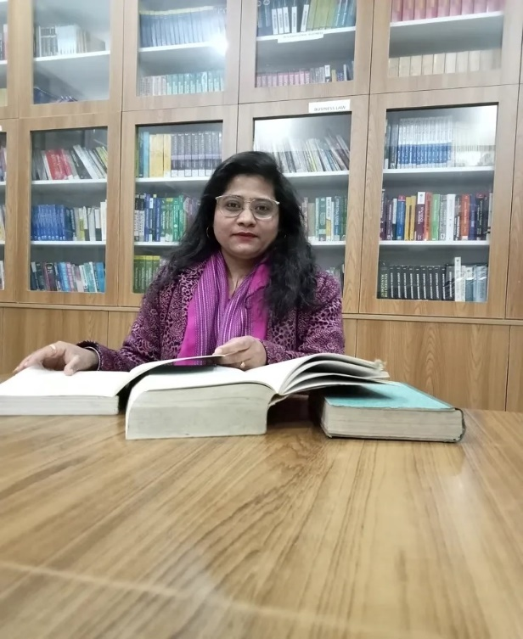

**Nupoor Bhandari**

**Assistant professor in Nimbus School of Education**

**Area**

Primary Area: Education

Secondary Area: Accounting, Finance, Auditing

**Contact**

Email: Nupoorbhandari27@gmail.com

Phone: +91-9997477910

**Education**

* Fellow Program in Education (Doctoral Degree), Himgiri Zee University
* Qualify NTA-NET in Education
* Qualify CTET 1 & CTET 2
* Master of Education, Birla campus Srinagar (HNBGU)
* Bachelor of Education, Army Institute of Education (GGSIPU)
* Master of Commerce, Bachelor of Commerce

**Teaching**

* Education
* Finance
* Guidance and counselling
* Management Accounting
* Corporate Accounting

**Research Area**

Sustainable development and vocational education

Information Communication Technology for Education

Guidance needs of students in the Indian context

Green skills and vocational education

Various psychological aspects

**Academic Experience**

Faculty Member, Nav Chetna College, Dehradun, January 2021 onwards

Faculty Member, Nimbus School of Education, September 2022 onwards

**Professional Experience**

Nimbus School of Education

Nimbus Academy of Management

**Selected Publications**

* Research Paper entitled “**The Inquiry of Vocational Education: In the Legacies of Dewey, Tagore, Gandhi**” Published in **the International Journal of Analytical and Experimental Model Analysis (IJAEMA)** February 2023**. (PP: 55-68) ISSN NO:0886-9367**
* Research Paper entitled “**Green Skill Awareness and its Importance in Vocational Education: The Indian Scenario**” Published in **the book Green Solutions: A Handbook for Sustainable Business Strategies** February 2024. **(PP: 235-243)** **ISBN: 978-81-971276-6-3**
* Research paper entitled**, “The Global 2030 Agenda: Vocational Education and Sustainable Development Goals in the Indian Context”** in **Intersectionality in Education: Promoting Equity Inclusivity and Sustainability ISBN: 978-91-989240-1-5**

**Academic Conferences**

* Research paper presentation in **National seminar** organized by **SGRR** in September 2023entitled **“Guidance need of adolescent students studying in government and private secondary school”.**
* Research paper presentation **in a Virtual first international conference** organized by **CTPD- DELHI** in October 2023 entitled**, “The Global 2030 agenda: Vocational Education and Sustainable Development Goals in the Indian context”.**
* Research paper presentation at a **national conference** organized by **Lakshmi Devi Tamta Women Education Center, Soban Singh Jeena University, Almora** on the topic of **changing dimensions of women's world** in December 2023paperentitled **“Empowering women for the stronger economy through skill development and vocational education”**

**FDP attended**

* Participation in a **five-day national virtual faculty development program on AI in education and business** organized by **the Department of Business Administration, Hindustan College of Arts and Science** in January 2024
* Participation in a **one-week National level virtual faculty development program** on **Use of Artificial Intelligence in Education 4.0 organized** by **Career Development Cell (CDC), Gokul Global University,** Siddhpur, Gujarat from 8 to 14 January 2024